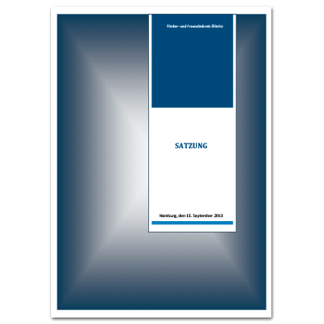

Friends and Supporters of Elliniko – Articles of association
The current articles of association are as follows:
Article 1 Name and registered office
- The name of the association is Förder- und Freundeskreis Elliniko e. V. (Friends and Supporters of Elliniko).
- The association is officially registered in Hamburg.
- The tax year is the calendar year. The first tax year ends on 31.12.2014.
Article 2 Purpose of the Association
The purpose of the association is to promote social engagement in the field of medical treatment and public healthcare and hygiene in the European Union.
The work being done by the Elliniko community clinic in Athens is one of the main examples of the activities supported by the association. The association is solely and exclusively for non-profit and charitable purposes, as defined in the Section 3 of the German General Tax Code (Articles 51 to 68).
The association will fulfill its purpose primarily through the following activities:
- support for the Elliniko community clinic and similar social or medical institutions in the European Union;
- support for activities in the field of health education;
- information and vocational training related to health policy in the European Union;
- public relations activities to further the association's work in Hamburg in support of the Elliniko community clinic and similar projects;
- promoting contacts and exchanges of information between skilled health professionals in Hamburg and other Member States of the European Union.
Article 3 Common public interest
The association is a non-profit organisation and does not seek to further its own financial ends. The financial resources of the association may only be used for the purposes described in the articles. Members do not receive benefits or share in any profit derived from the association's capital. No-one may benefit from any expenditure which is not in line with the purpose of the association or through disproportionately high renumeration.

Article 4 Membership
Any adult physical person or any legal entity may become a member of the association. Applications for membership shall be in writing and the board reserves the right to refuse any application within one month of receiving it.
Membership shall be terminated upon:
- death;
- resignation;
- expulsion from the association.
Resignation is only possible at the end of the calendar year. Three months' notice must be given in writing prior to resignation.
Membership fees shall be paid. The general assembly decides on the amount and date upon which membership fees are due.
In the event of serious failure to abide by the terms of membership, including non-payment of membership fees (only one reminder will be sent), the board may decide to expel a member.

Article 5 The bodies of the association
The bodies of the association are:
- the general assembly, which is the highest decision making body;
- the board.

Article 6 General assembly
The general assembly shall be convened annually by means of a written notice to be sent to all members two weeks in advance by at least two members of the board.
The general assembly is deemed to be quorate when it has been duly convened. Members can take ordinary decisions by simple majority of those present. Decisions concerning amendments to the articles of association can only be taken by a 2/3 majority of the members present at the general assembly. Any decision to dissolve the association can only be taken by a 2/3 majority of all members. Members who abstain from voting shall be considered not present. The decisions of the general assembly shall be recorded in writing.

Article 7 Rights and obligations of the general assembly
- To decide on the number, election, appointment and dismissal of the board;
- To approve the annual report of the board and decisions regarding the association's budget;
- To amend the articles of association, the purpose of the association and to dissolve the association;
- To decide on the number and election of auditors and to approve their report.

Article 8 Authorisation of the board to represent the association pursuant to Article 26 of the German Civil Code
The board shall comprise a chairperson and vice-chairperson. Each member of the board is entitled to represent the association. Any physical person who is a member of the association at the time of voting may stand for election.
If a member of the board terminates his/her membership of the association, he/she shall also resign from the board.

Article 9 Board of management/advisory board
The general assembly decides whether to elect additional members of the board of management who are not authorised to represent the association, and how many such members.
The board is responsible for all association matters that are not explicitly entrusted to the general assembly.
The board takes decisions by simple majority. Decisions shall be recorded in writing. There is a quorum when at least two members of the board are present.
Board members who are authorised to represent the association individually are bound by majority decisions taken by the board.
The board is elected for a term of two years.
The board remains active until such time as a new board has been elected.
The board is authorised to appoint a manager to take charge of the association's current business.
Should any articles of the association prevent the official registration of the association or the recognition of the common public interest of the association by the relevant tax office, the board is authorised to make the requisite amendments independently.

Article 10 Audit
The general assembly shall elect at least one auditor. The tasks of the auditor(s) are to examine the accounts and ensure compliance with the articles of the association and the implementation of its decisions.

Article 11 Dissolution/Loss of special tax status
In the event of the association being dissolved or losing its special tax status as a non-profit organization, the assets of the association shall be transferred to the "Sternenbrücke e. V. Hamburg" association (Sternenbrücke children's hospice), which may use the proceeds for charitable, benevolent or ecclesiastical purposes only.

Article 12 Arbitration agreement
The attached arbitration agreement is part of the articles of association.

(Published by the "Förder- und Freundeskreis Elliniko e. V." (Friends of Supporters of Helleniko) on Wednesday 2 October 2013 under "Association)

